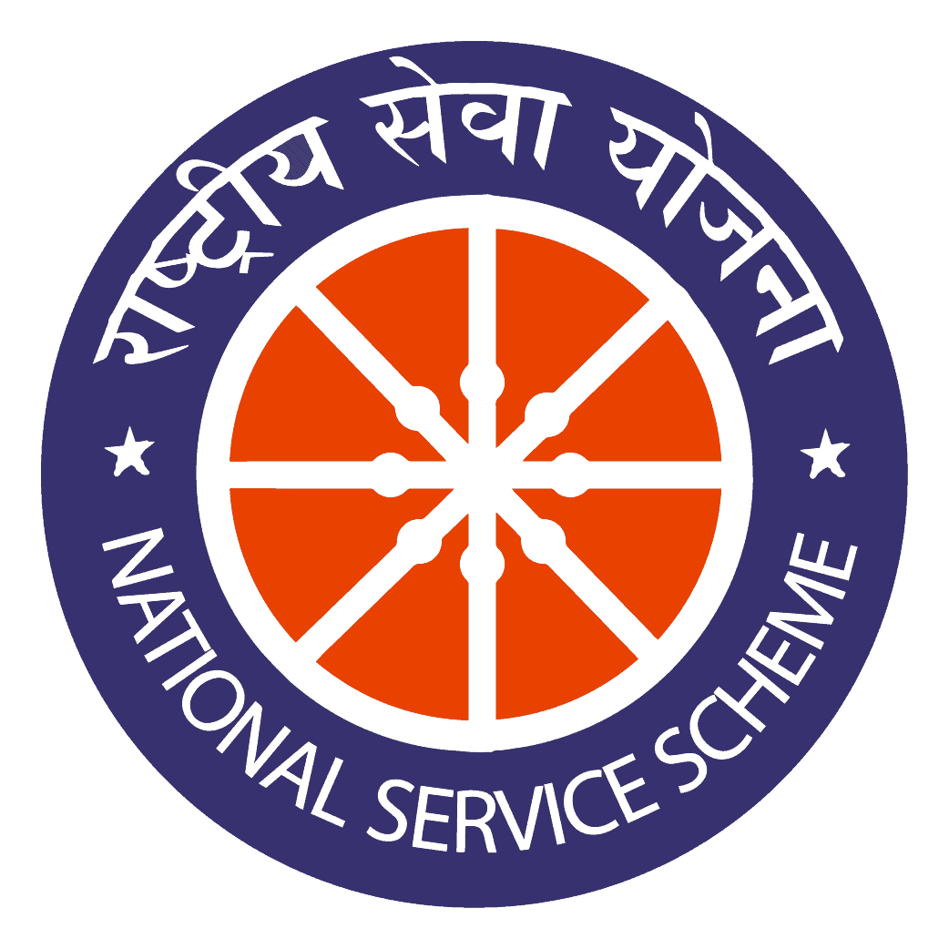

Regular Activities

Date: 21.06.2020

INTERNATIONAL YOGA DAY

On the date of 21st June 2020, the International Yoga Day was celebrated at our home with family members based on the theme “Yoga at home and with family”. The Principal of Jamal Mohamed College, and more than 50 Volunteers were participated in this programe. We organized the programe very well.

Number of NSS Volunteers Participated: 50

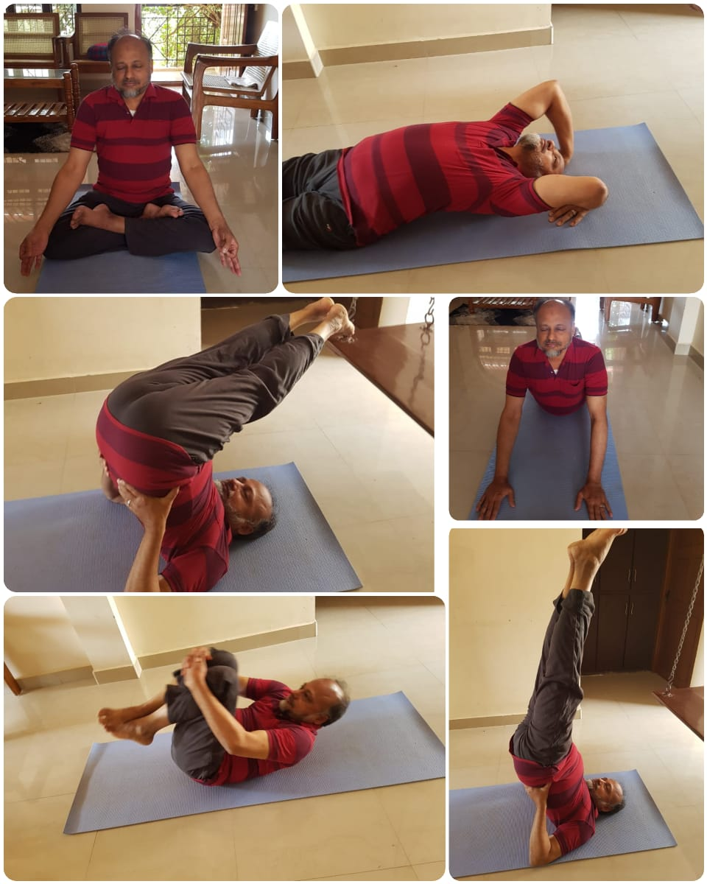

Our beloved Principal DR S.ISMAIL MOHIDEEN is practicing various asanas at his home on the International Yoga Day.
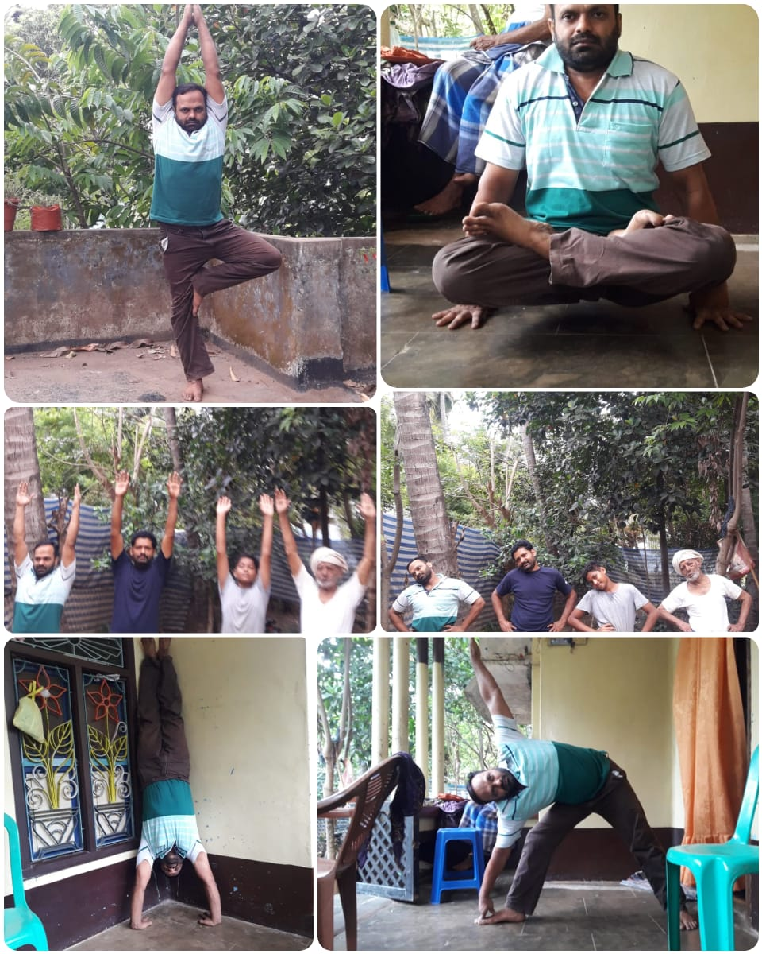
DR.B.MOHAMED RAFEEQ with his Family, Department Of Economics, NSS Programme Officer, Jamal Mohamed College.

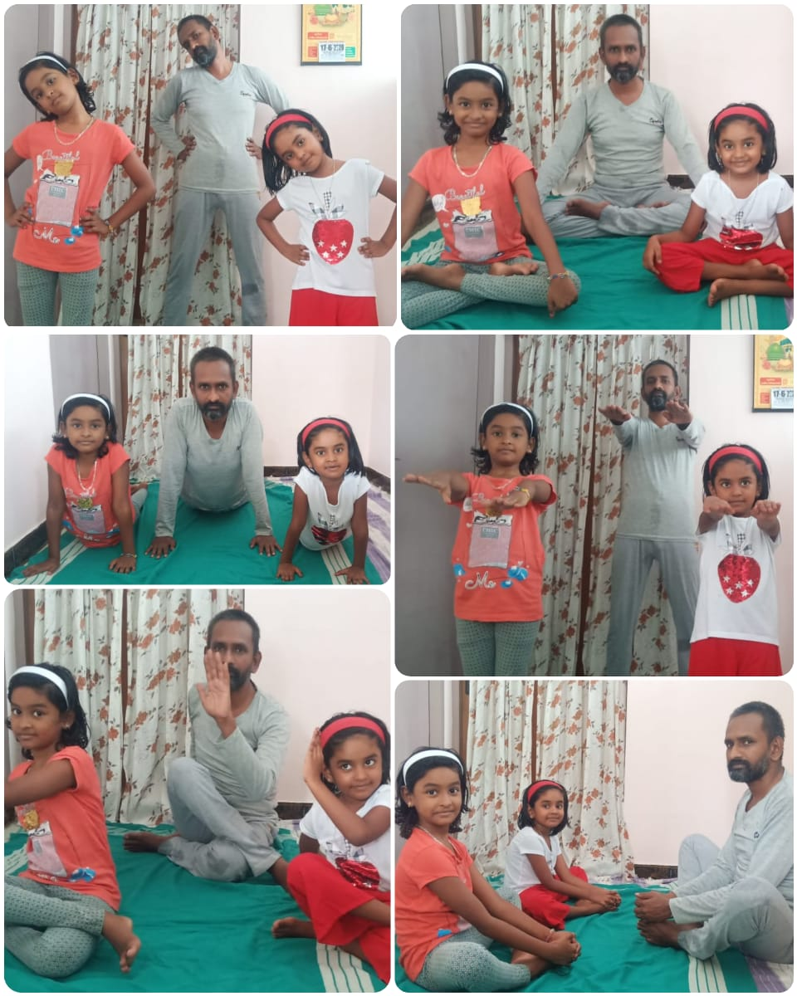
DR.S. MOHAMED YUSUFF ANSARI with his Family, Department Of Mathematics, NSS Programme Officer, Jamal Mohamed College.

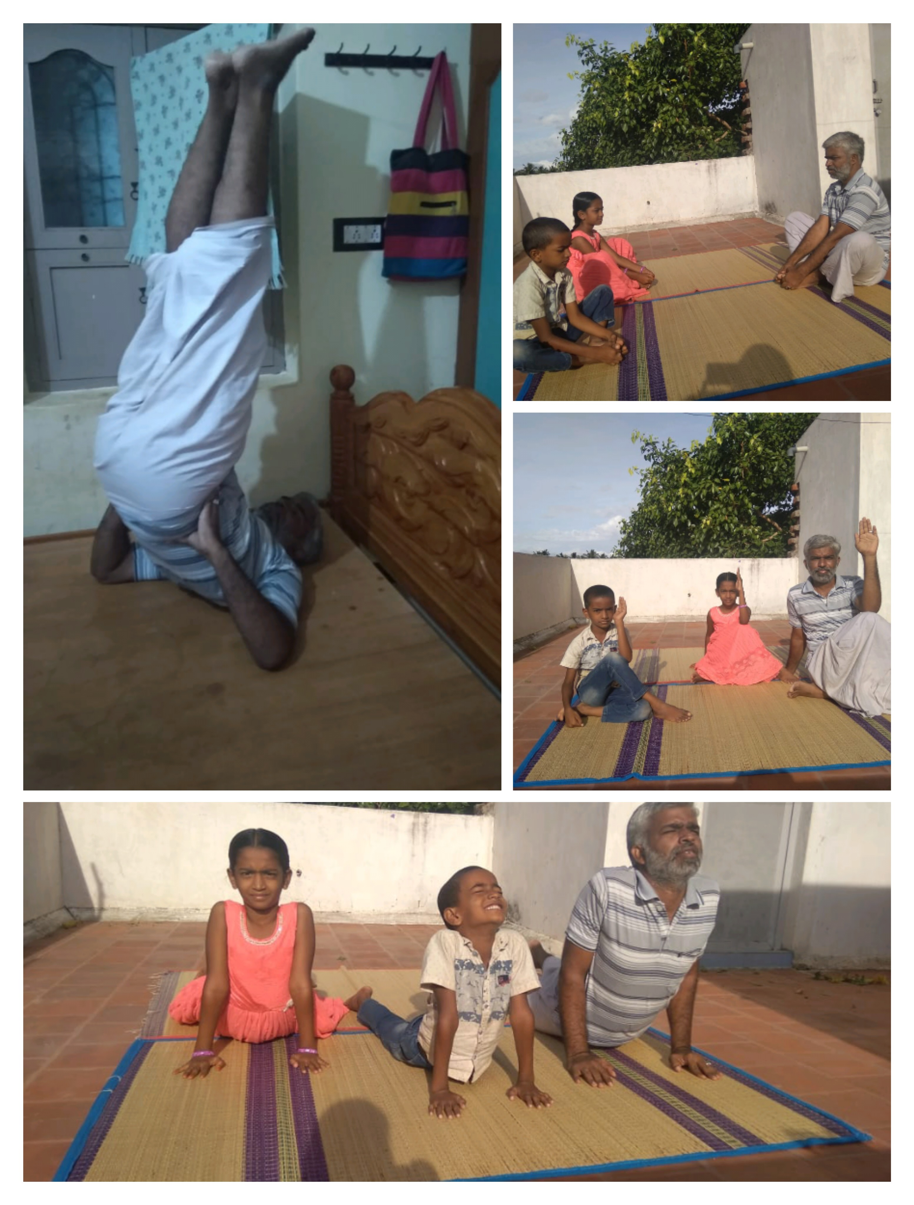
DR.L.ASHID AHAMED with his Family, Department Of Commerce, NSS Programme Officer, Jamal Mohamed College.
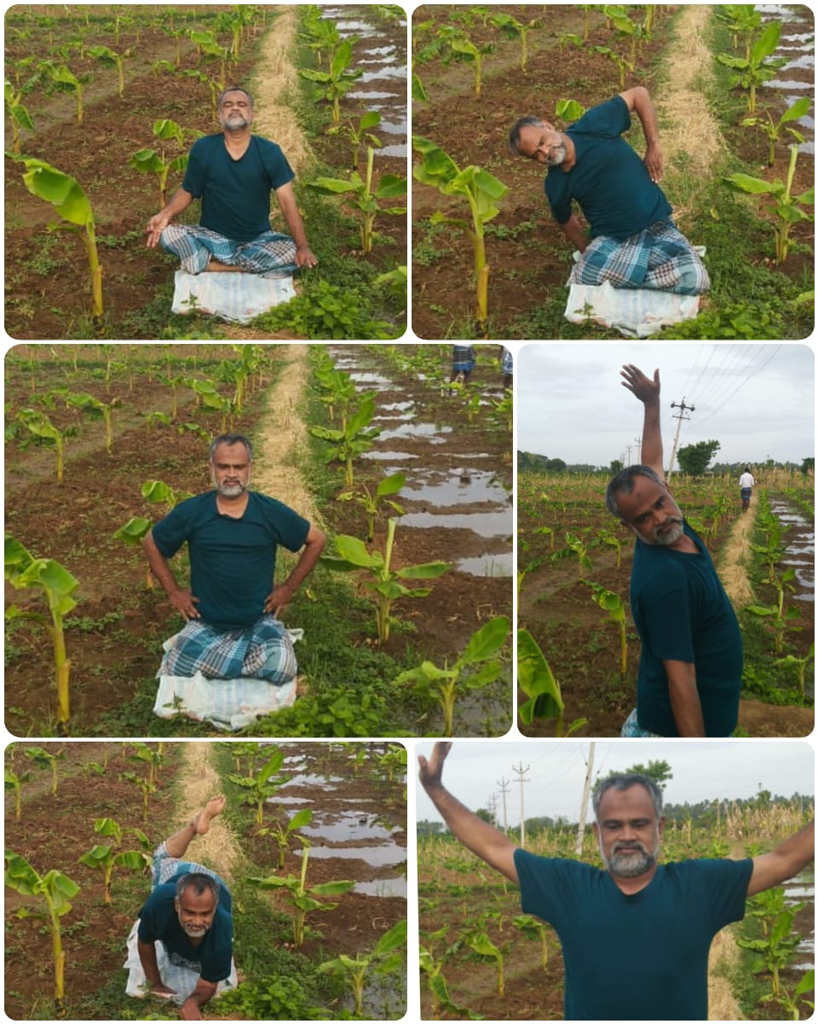
MR.B.MOHAMED FAIZE BASHA Department Of Computer Science, NSS Programme Officer, Jamal Mohamed College.
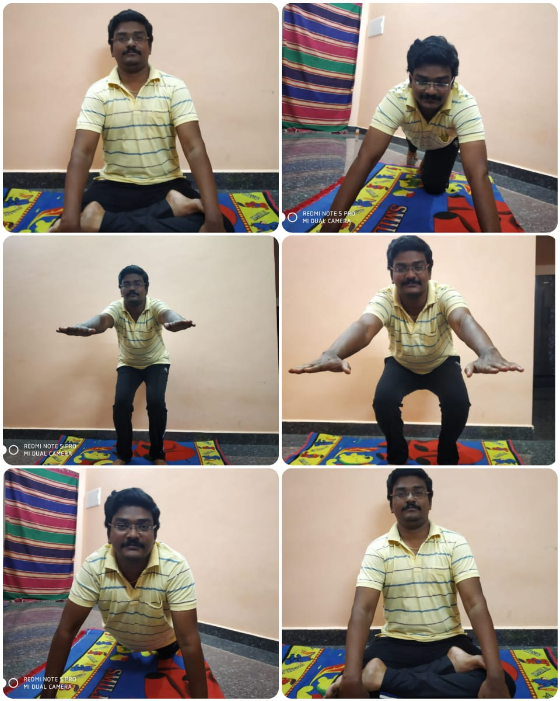
DR S.GOPI department Of Commerce, NSS Programme Officer, Jamal Mohamed College.

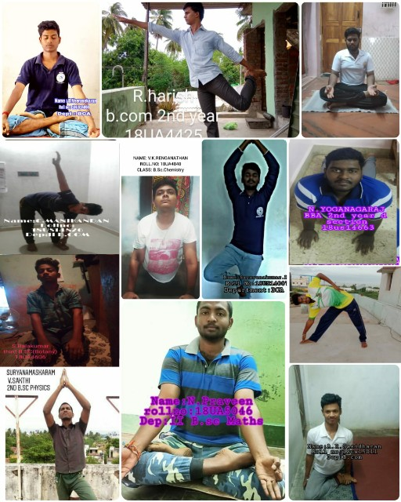

DATE: 26.06.2020

INTERNATIONAL DAY AGAINST DRUG ABUSE

On the date of 26th June 2020, the International Day Against Drug Abuse programme was conduct by JMC NSS at home. The NSS Volunteers were taken pledge at home. We organized the programe and completed with good manner.

Number of NSS Volunteers Participated: 20

DATE: 11.07.2020

WORLD POPULATION DAY

On the date of 11th July 2020, the World Population Day programme was conduct by JMC NSS at home. The NSS Volunteers were taken pledge with slogan at home with my guidance.

Number of NSS Volunteers Participated: 30

DATE: 28.07.2020
WORLD NATURE CONSERVATION DAY
QUIZ COMPETITION 2020
On the date of 28.07.2020, the World Nature Conservation Day Quiz competition was conducted by NSS of Jamal Mohamed College through online mode. The registration link was circulated all over India on 21.07.2020. The registration link was opened from 21.07.2020 to 25.07.2020. On 28.07.2020 the Competition link was sent through Whatsapp group.The E-Certificate provided to the participants who got 40 and above points. NSS Programme Officers, NSS Volunteers, Faculty members and other students participated in this Quiz competition.

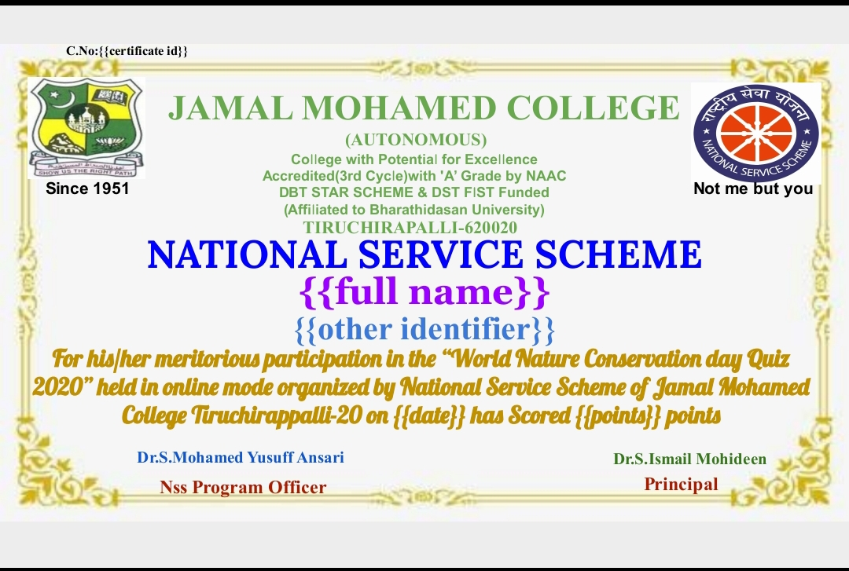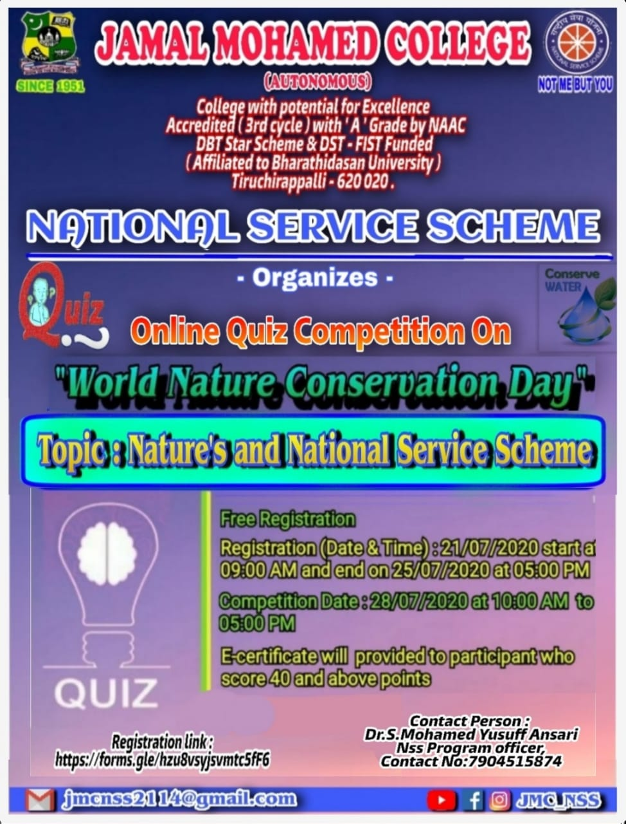
Date : 30.07.202

NATIONAL HOSPITAL DAY 2020

On the date of 30.07.2020, the National Hospital Day 2020 programme was conducted by National Service Scheme of Jamal Mohamed College.NSS programme officers and NSS volunteers have shown their views on hospital, Doctors and nurses on video. The programme was completed in a good manner.

No. of NSS Volunteers participated : 23

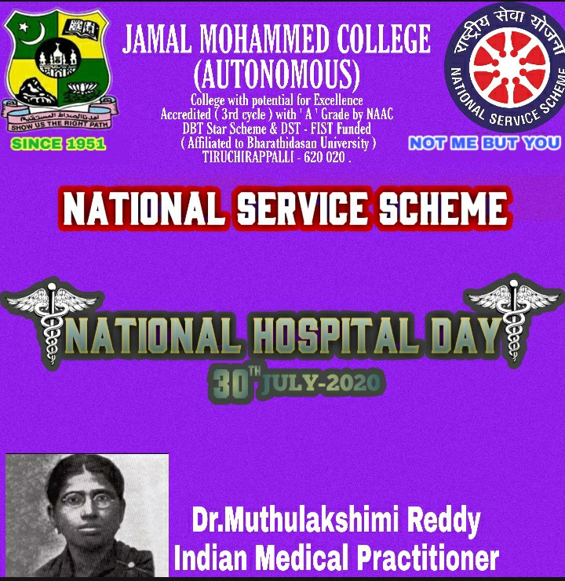
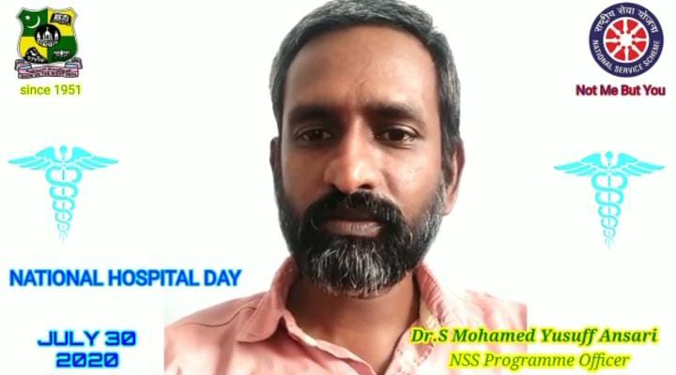
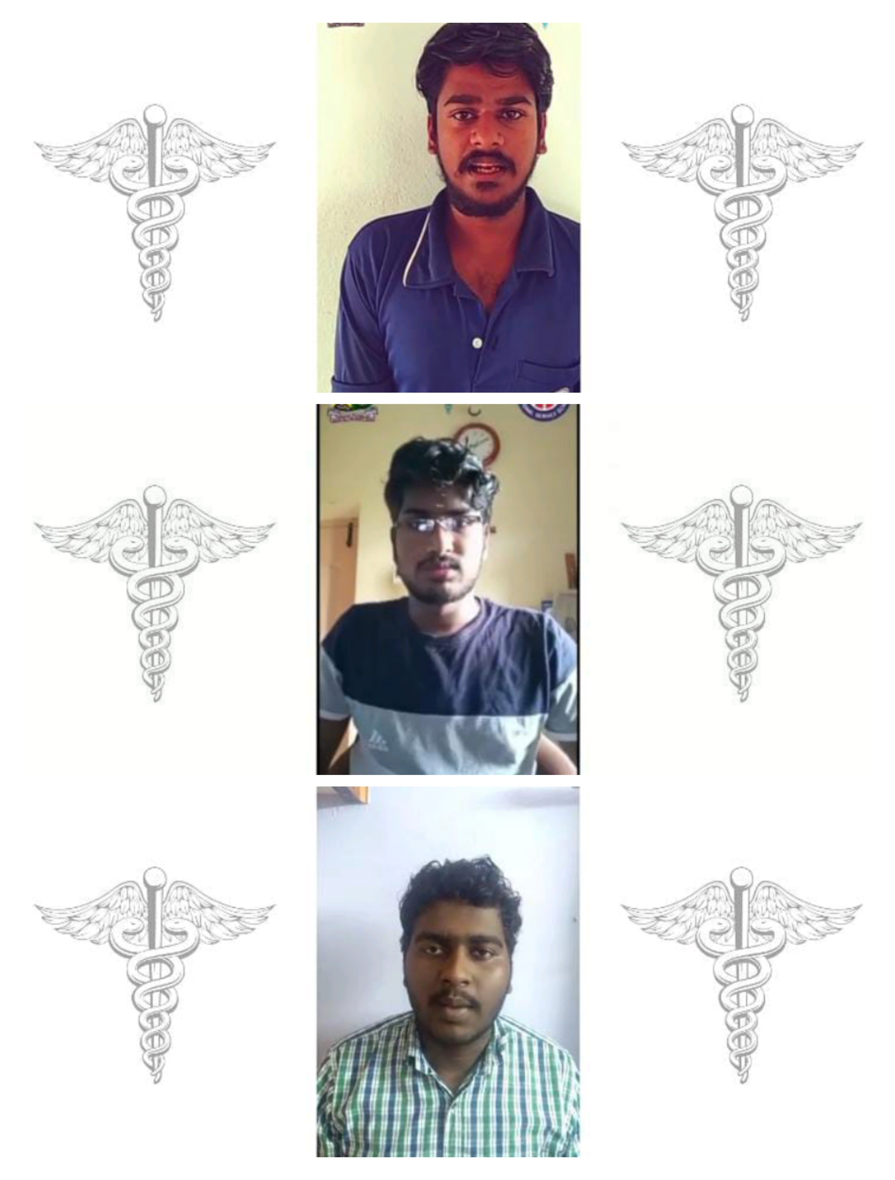
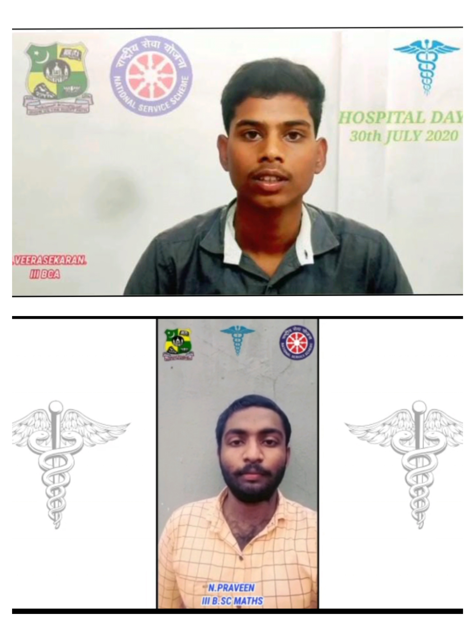

_{Date: 12.08.2020}
INTERNATIONAL YOUTH DAY

On the date of 12th August 2020, the International Youth Day Pledge and Quiz Competition was conducted by National Service Scheme of Jamal Mohamed College through online mode. The registration link was circulated all over the Jamal Mohamed College on 09.08.2020.The Registration link was opened from 09.08.2020 to 11.08.2020. On 12.08.2020 the competition link was sent through WhatsApp Group.The E- Certificate provided to the participates who got 40 and above points. NSS Programme officers ,NSS volunteers, faculty members, and other students participated in the Quiz competition.

Total no. Of Registration : 101
Total no. Of Participants : 82

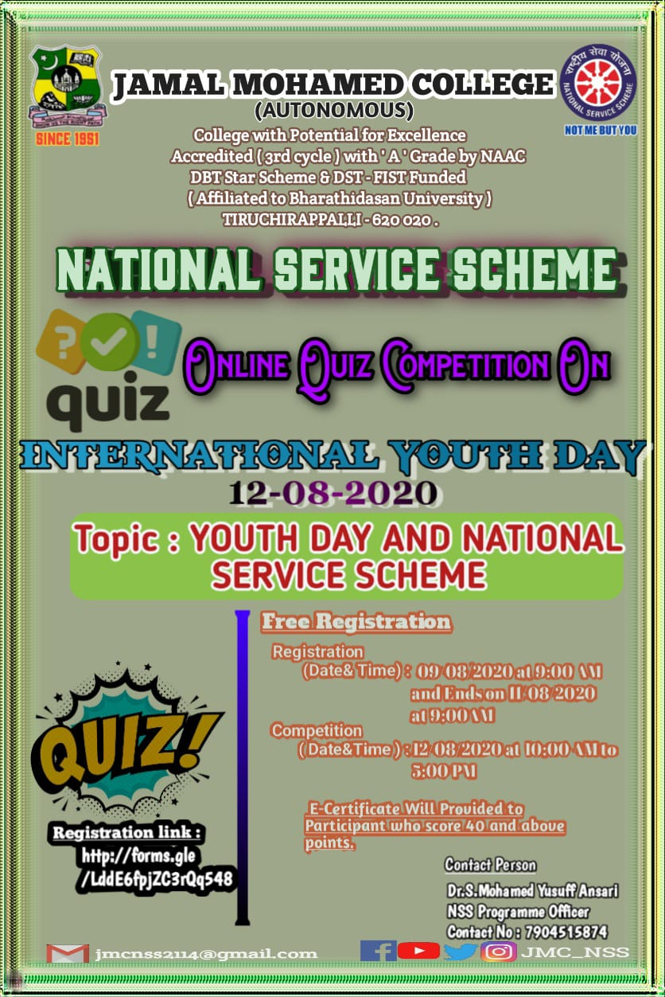
Date : 15.08.2020

74th INDEPENDENCE DAY
On the date of 15.08.2020, the 74th Independence Day was celebrated by National Service Scheme of Jamal Mohamed college. NSS programme officers and NSS volunteers have shown their views to our Freedom Fighters on video. The volunteers to organized the program very well.

Total no. of volunteers participants : 22

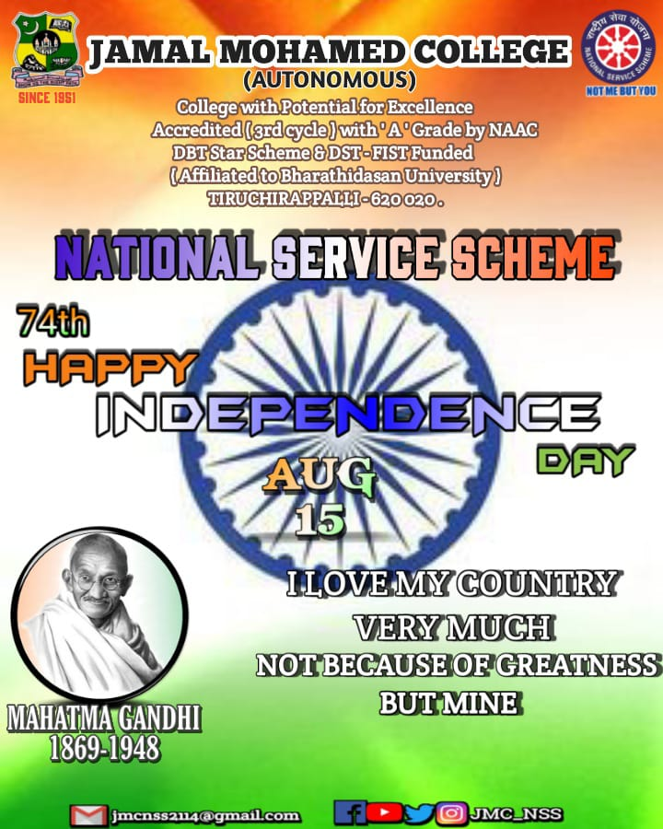
DATE: 16.08.2020

MINISTRY OF YOUTH AFFAIRS AND SPORTS

On the date of 16th July 2020, the Ministry of Youth Affairs and Sports conducted the programme based on the theme “YOUTH FOR NEP,2020”. They conducted through WEBINAR LIVE at 1 P.M to 3 P.M, Many Special speakers and Minister's spoke in Live. NSS programme officers and Volunteers of Jamal Mohamed College participated in this programme. Our Volunteers did their duty in a best manner.
Number of NSS Volunteers Participated: 25

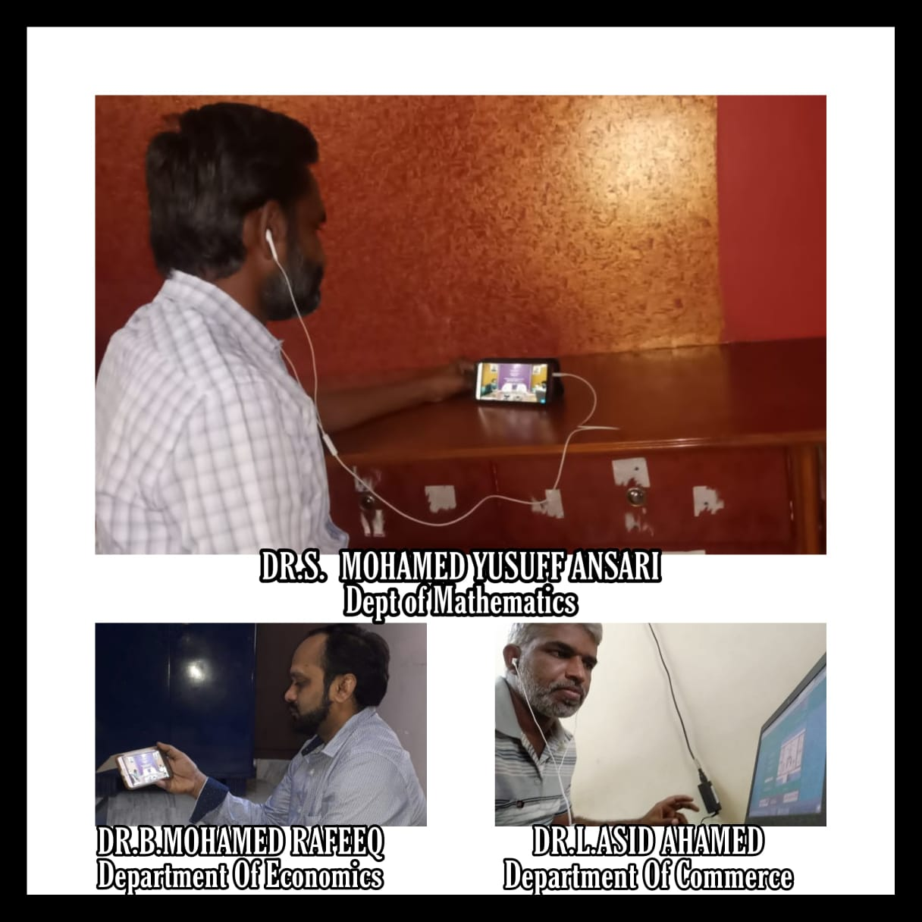
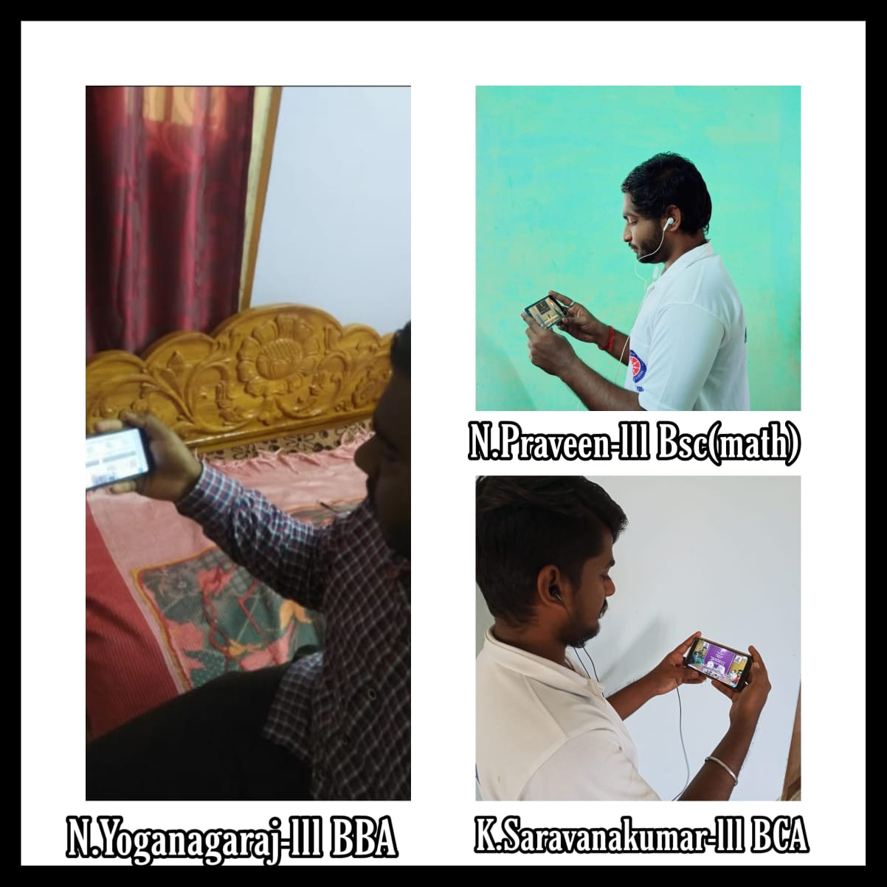
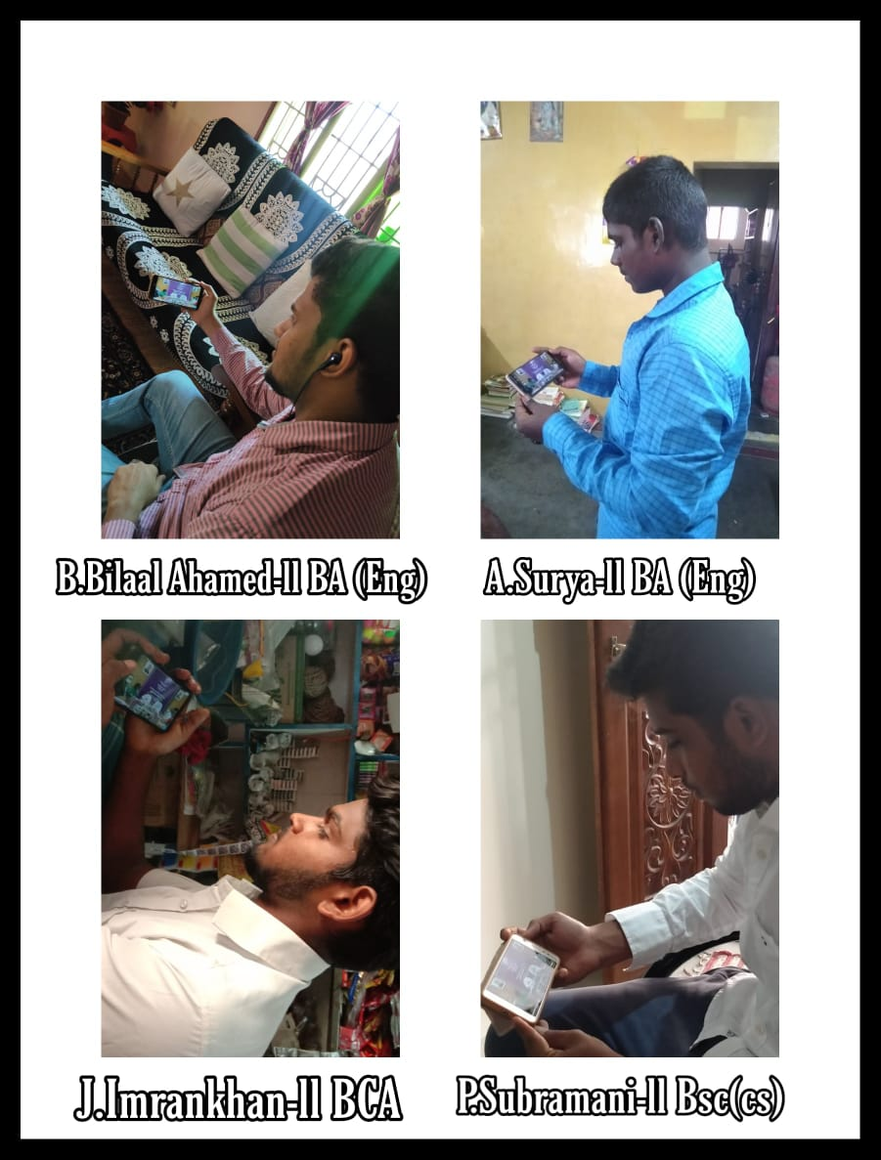
Date : 19.08.2020
WORLD HUMANITARIAN DAY

On the date of 19.08.2020, the World Humanitarian Day was celebrated by National Service Scheme of Jamal Mohamed college. NSS programme officers and NSS volunteers helped the needy people in our society by giving Masks, Hand Sanitizer and kabasura kudineer to them. We organized the programme very well.

Total no. of volunteers participant : 17

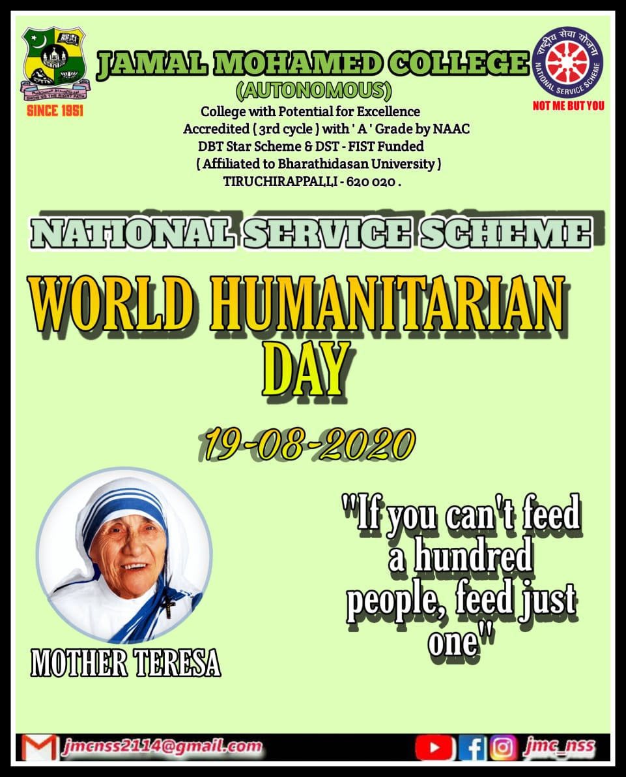
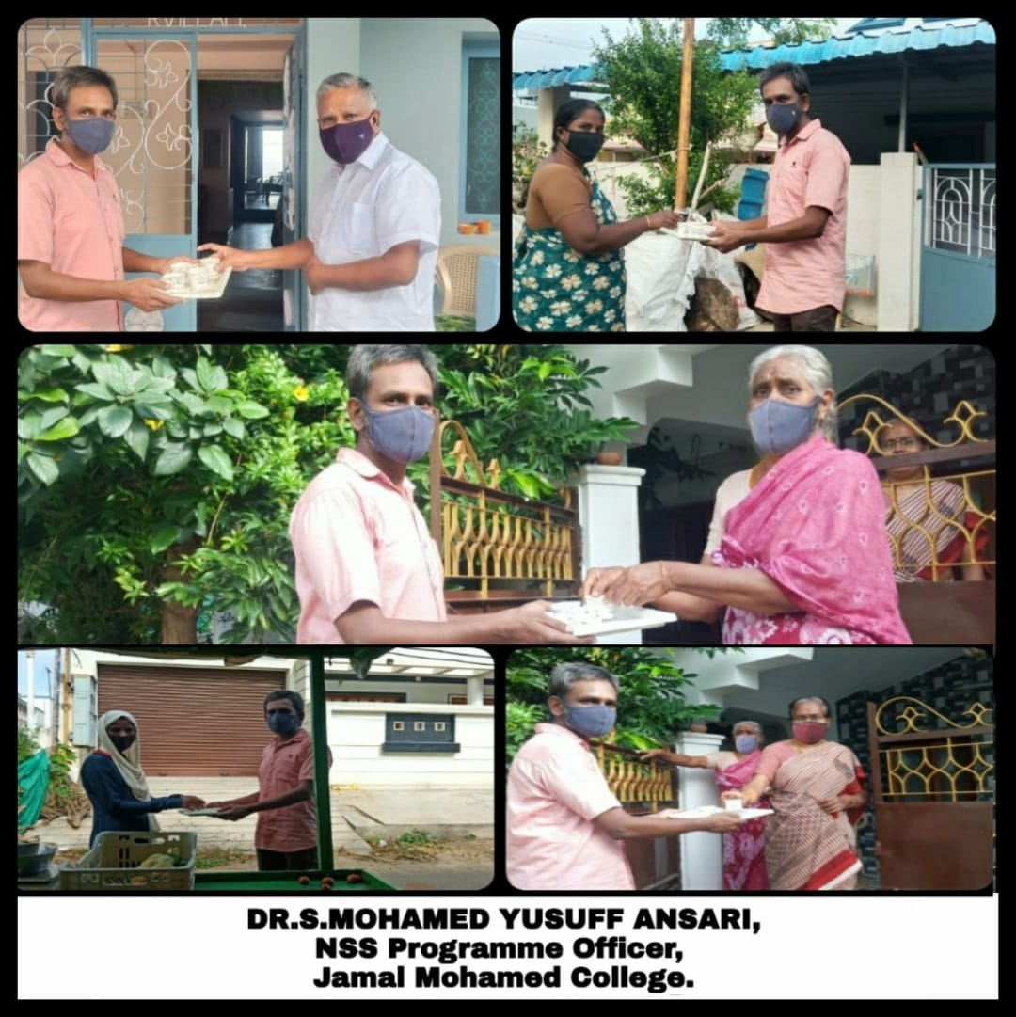
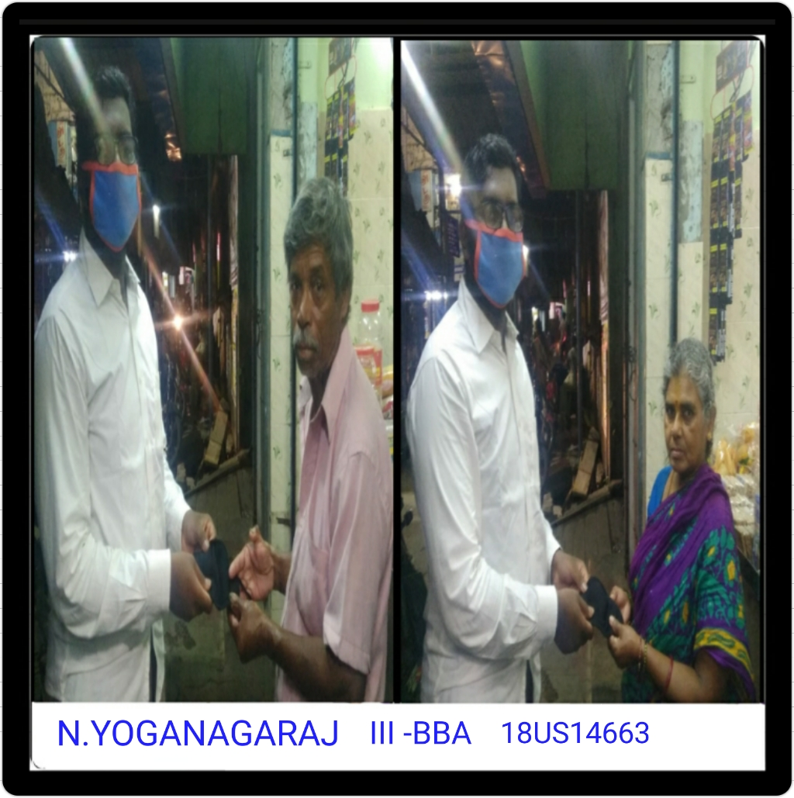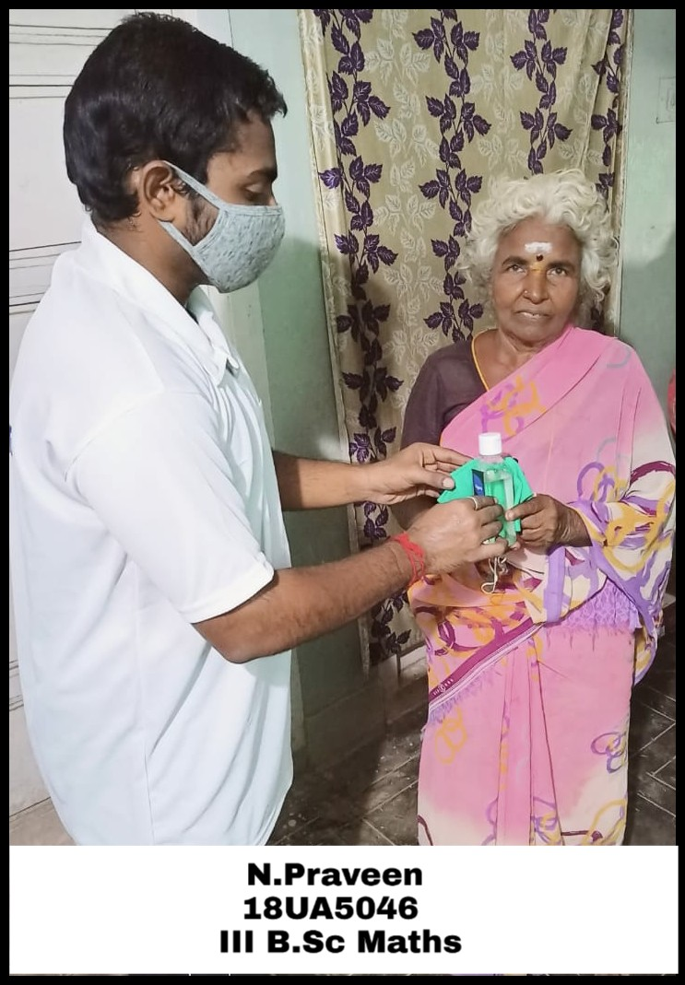

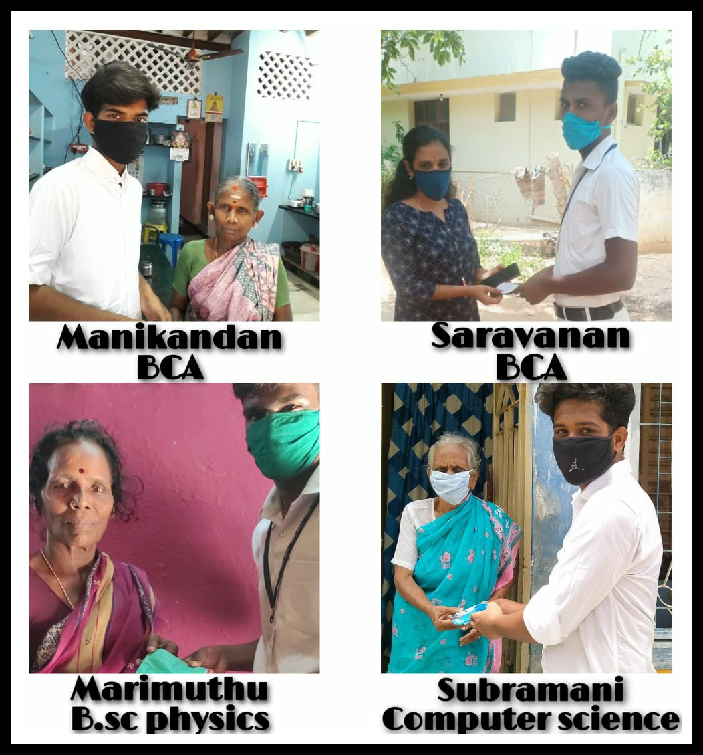

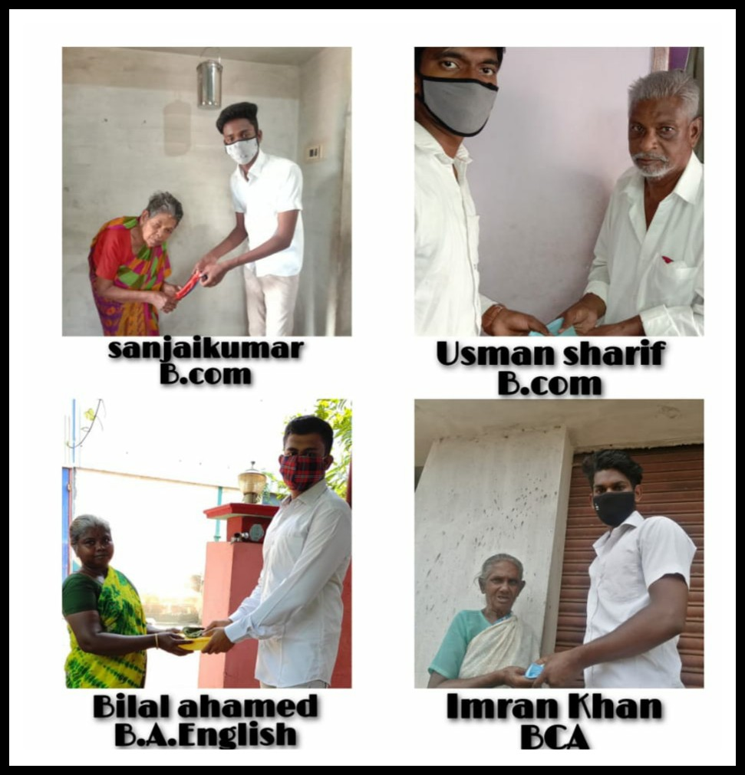

FIT INDIA YOUTH CLUB

As per the instruction given by Ministry of Youth Affairs and Sports, Govt. of India and Regional Directorate of NSS, We, NSS Programme Officers and NSS Volunteers, are participating in the Fit India Freedom Run from 15th August to 2nd October. We are aware about the importance of physical fitness and spend 30 to 60 minutes daily for group physical activities. We are practicing the two activities suggested by the authority from 26 August to 14th September 2020. On the date of 26.08.2020 we have done outdoor activity and indoor activity for fit India freedom run.

REGIONAL DIRECTORATE OF NSS, CHENNAI

NAME OF THE INSTITUTION: Jamal Mohamed College ( Autonomous)

Fit India Movement Report
Duration of the Program: From 26.08.2020 To 14.09.2020

Name of Activities conducted | No. of Activities conducted | Types of Physical Fitness Activities undertaken | No. of Families conducted Fitness Activities | No. of Youth Volunteers, Families and others undertook Physical Activities
 |  |  |  | Male | Female | Total
Orientation Awareness,  Planning Training | Nil | Nil | Nil | Nil | Nil
Fitness @ Home, Fitness with Family | 01 | Yoga | 03 | 17 | 03
Outdoor selected Activities | 01 | Walking | Nil | 12 | Nil
Others, if any | Nil | Nil | Nil | Nil | Nil
Grand Total

Place: Trichy
Date: 26/8/2020

FIT INDIA YOUTH CLUB
DAY 1
Date : 26.08.2020
Activity: I
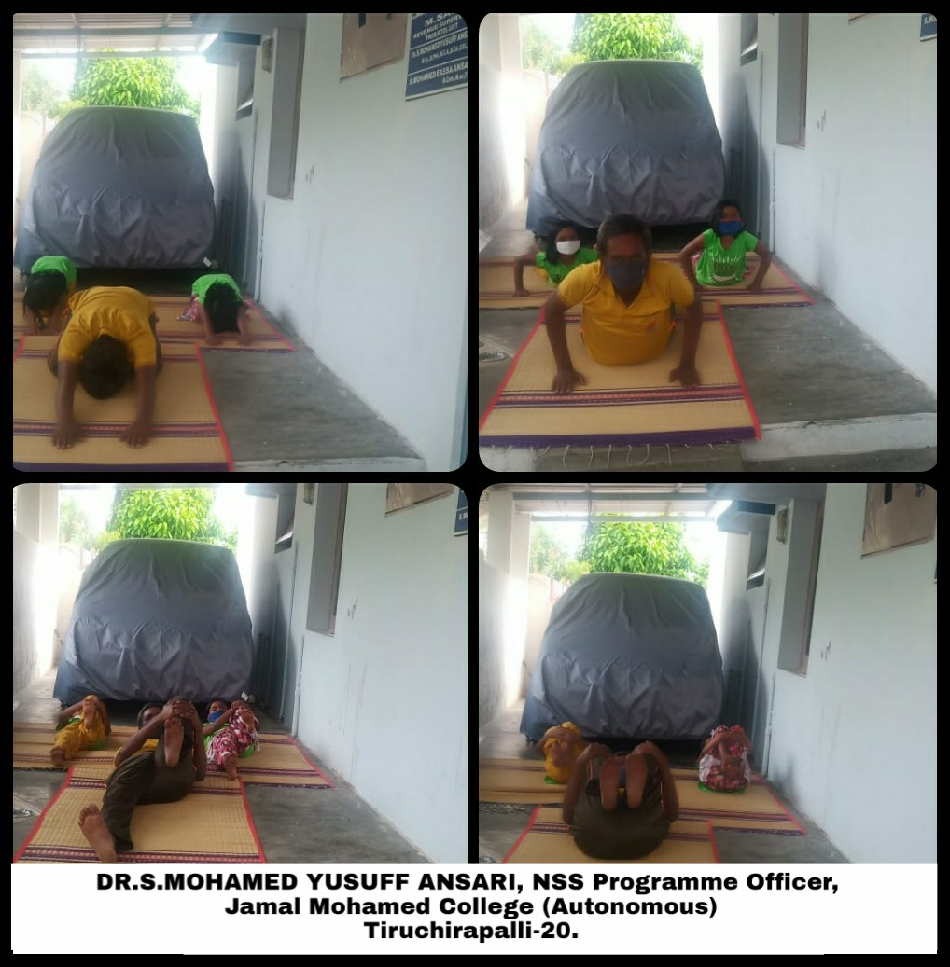
_{Volunteers}
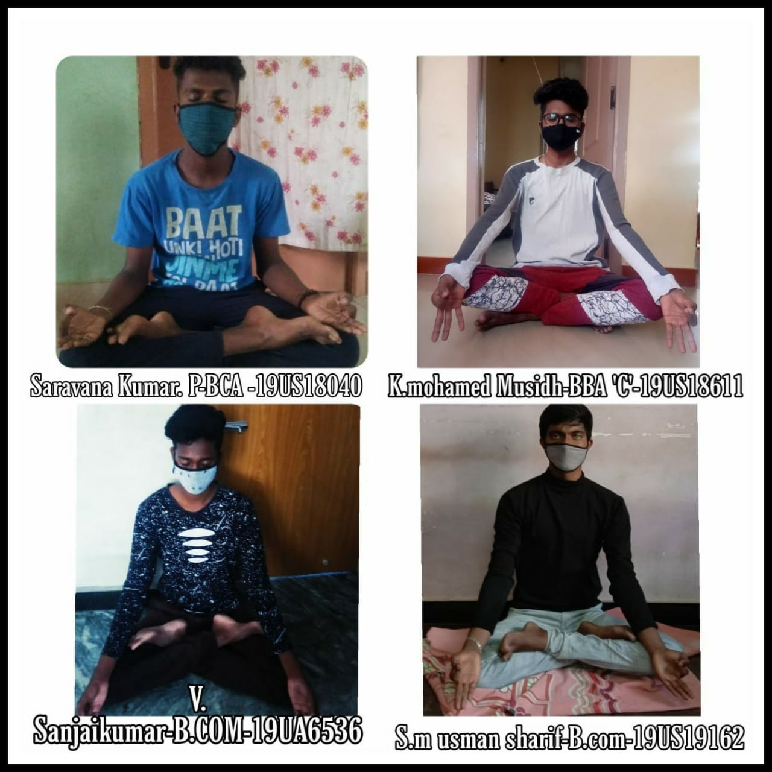Activity II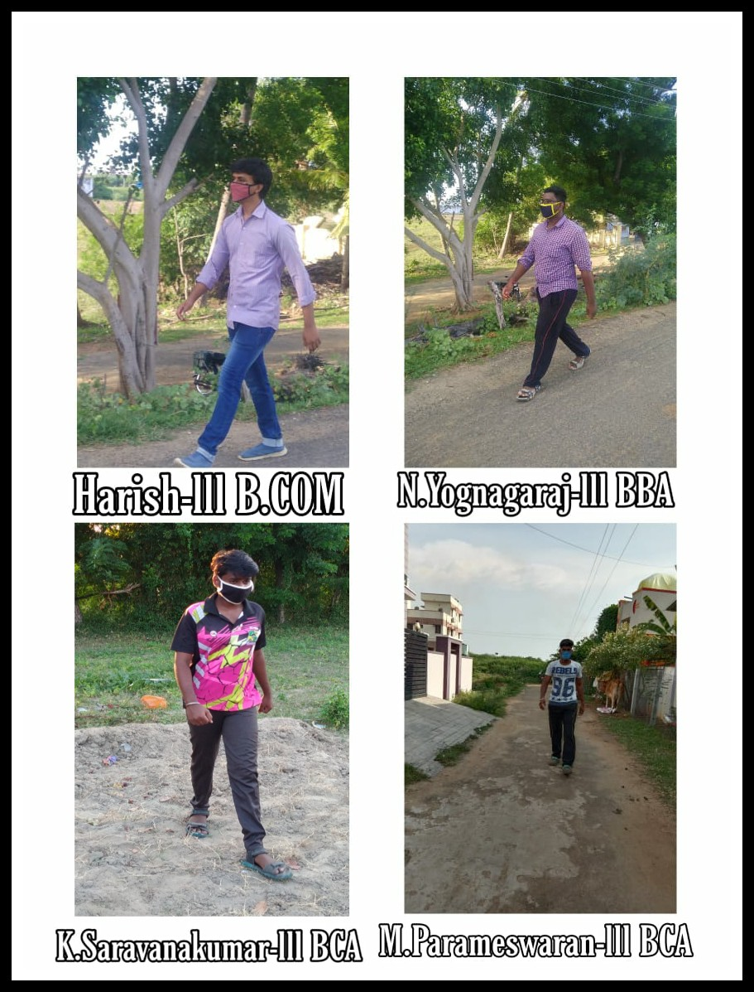

FIT INDIA YOUTH CLUB
DAY 2
Date : 27.08.2020
Activity: I
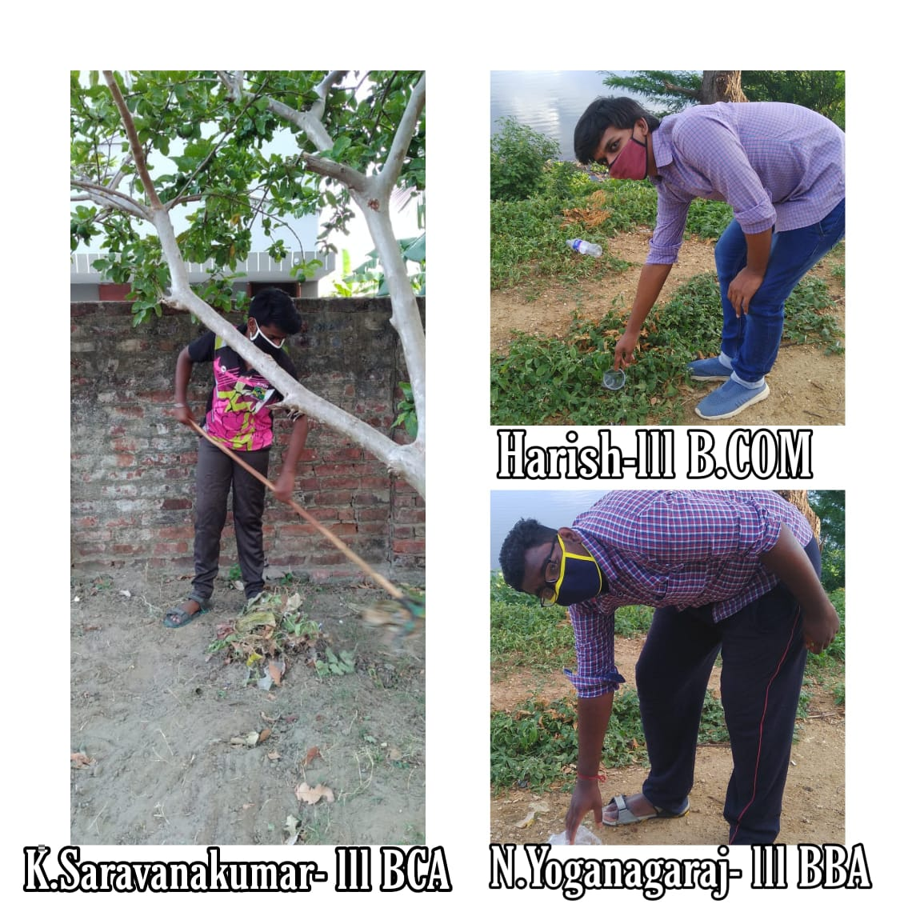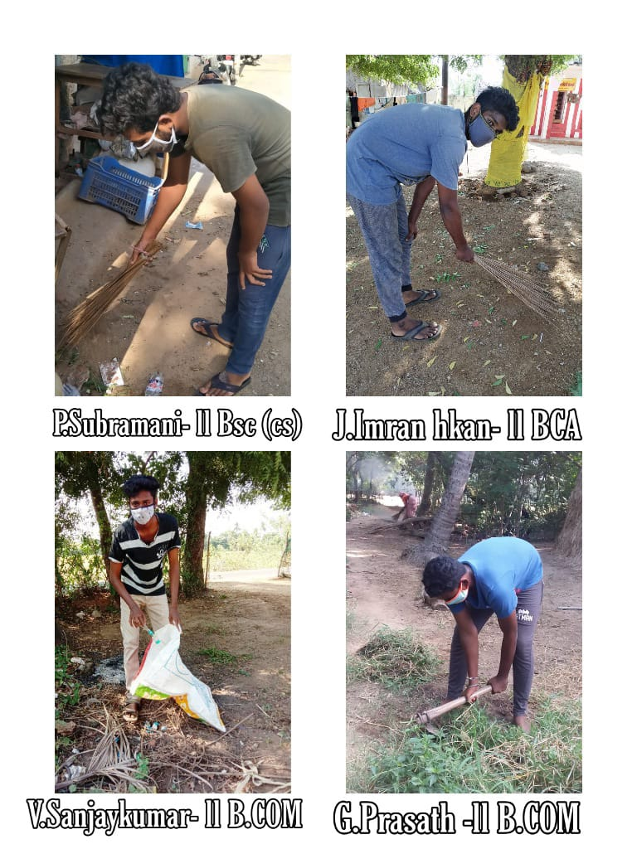
FIT INDIA YOUTH CLUB
DAY 3
Date : 28.08.2020
Activity: I
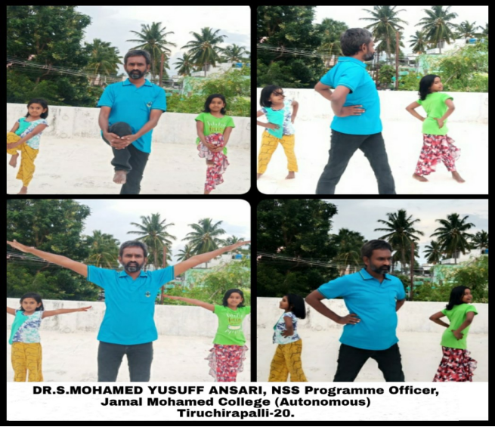
_{volunteers}
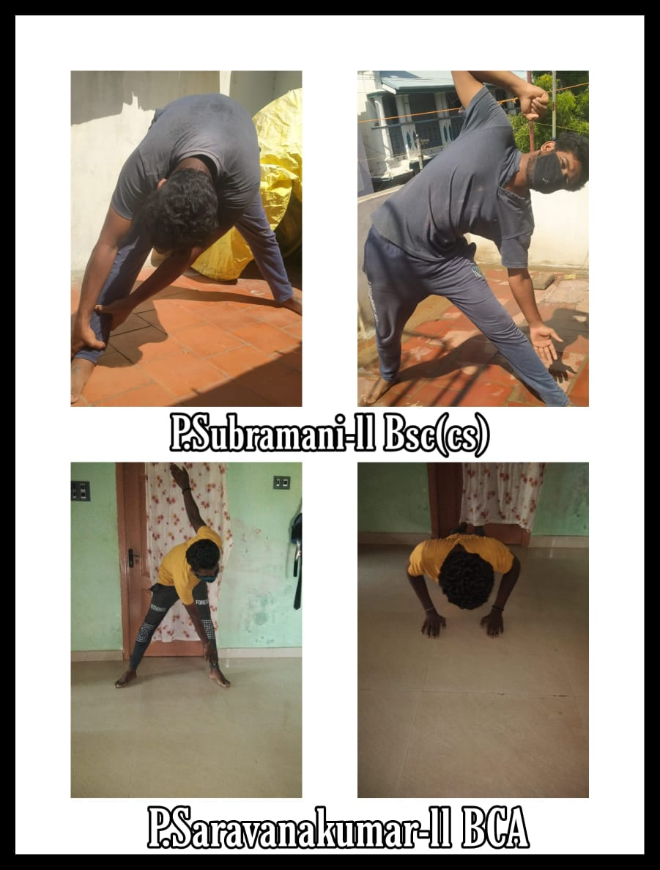
Activity: II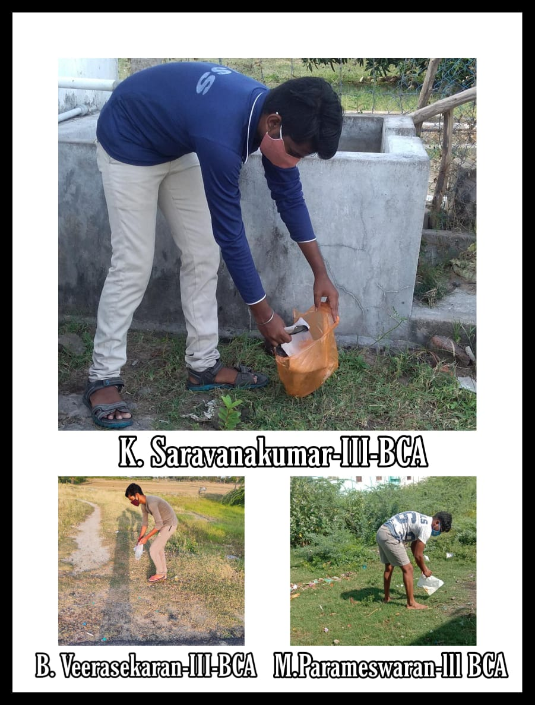
Date : 02.09.2020

MAHATMA GANDHI BIRTHDAY
On the date of 02nd October 2020, the Mahatma Gandhi Birthday was celebrated. Quiz Competition was conducted by National Service Scheme of Jamal Mohamed College through online mode.On 02.09.2020 the competition link was sent through WhatsApp Group. The E- Certificate provided to all the participates. NSS Programme officers ,NSS volunteers, faculty members, and other students participated in the Quiz competition. The programe successfully completed successfully.

Total No. Of Participants : 104

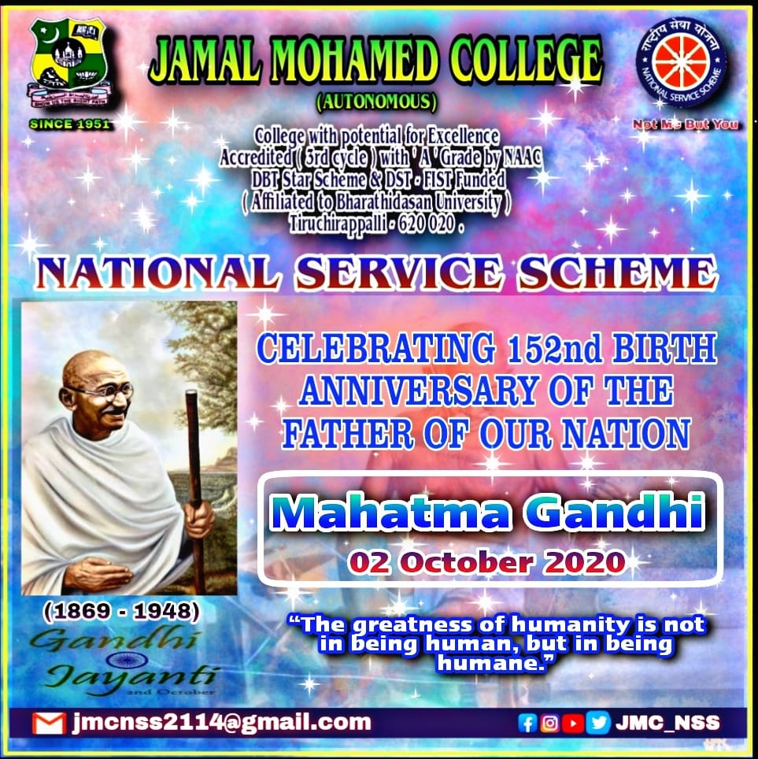
FIT INDIA YOUTH CLUB
As per the instruction given by Ministry of Youth Affairs and Sports, Govt. of India and Regional Directorate of NSS, We, NSS Programme Officers and NSS Volunteers, are participating in the Fit India Freedom Run from 15th August to 2nd October. We are aware about the importance of physical fitness and spend 30 to 60 minutes daily for group physical activities. We are practicing the two activities suggested by the authority from 26 August to 14th September 2020. On the date of 13.09.2020 we have done outdoor activity and indoor activity for fit India freedom run.

DAY 13
Date : 07.09.2020
Activity: I

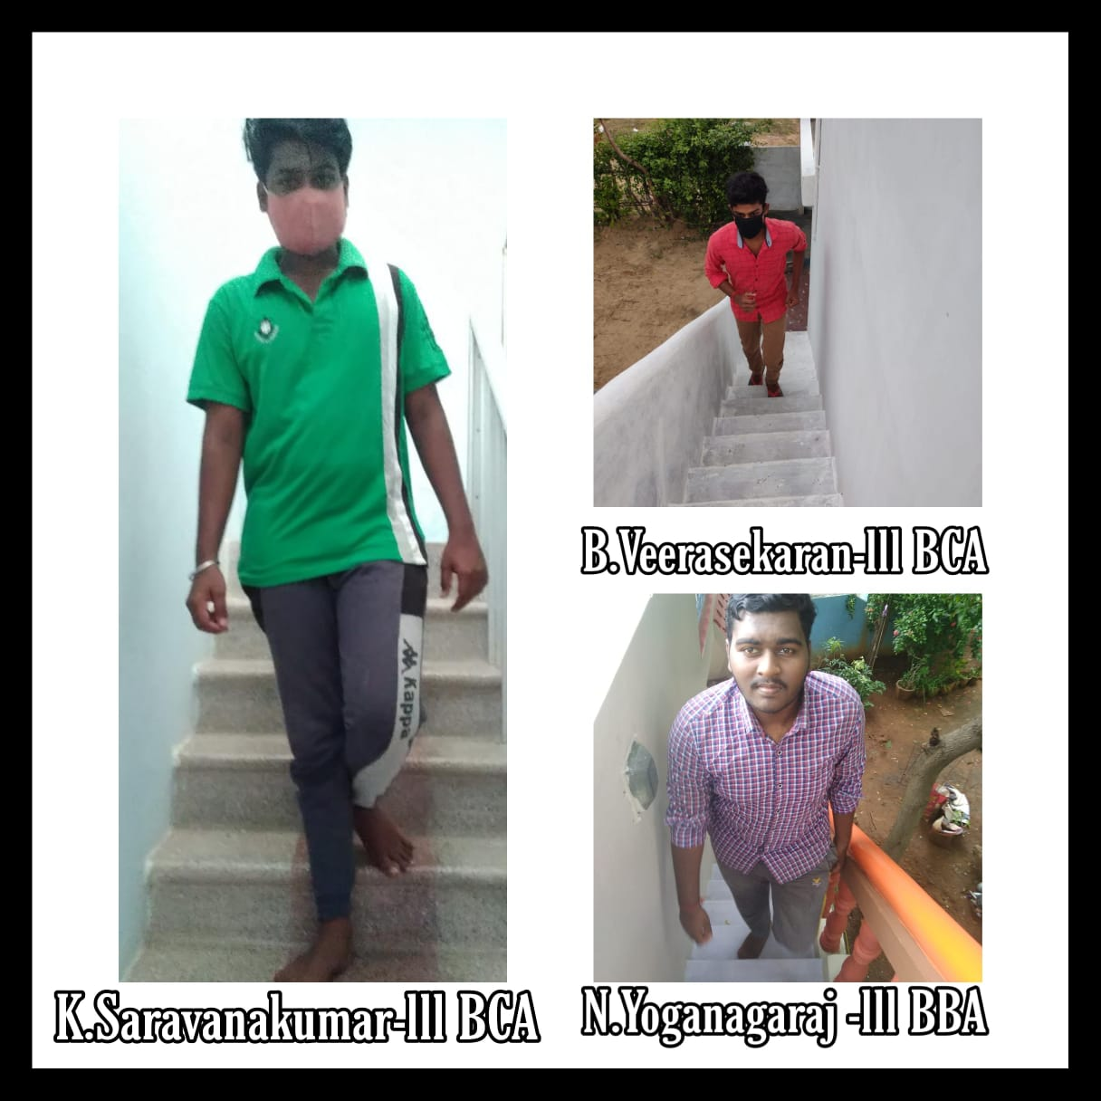
FIT INDIA YOUTH CLUB
DAY 20
Date : 14.09.2020
Activity: I
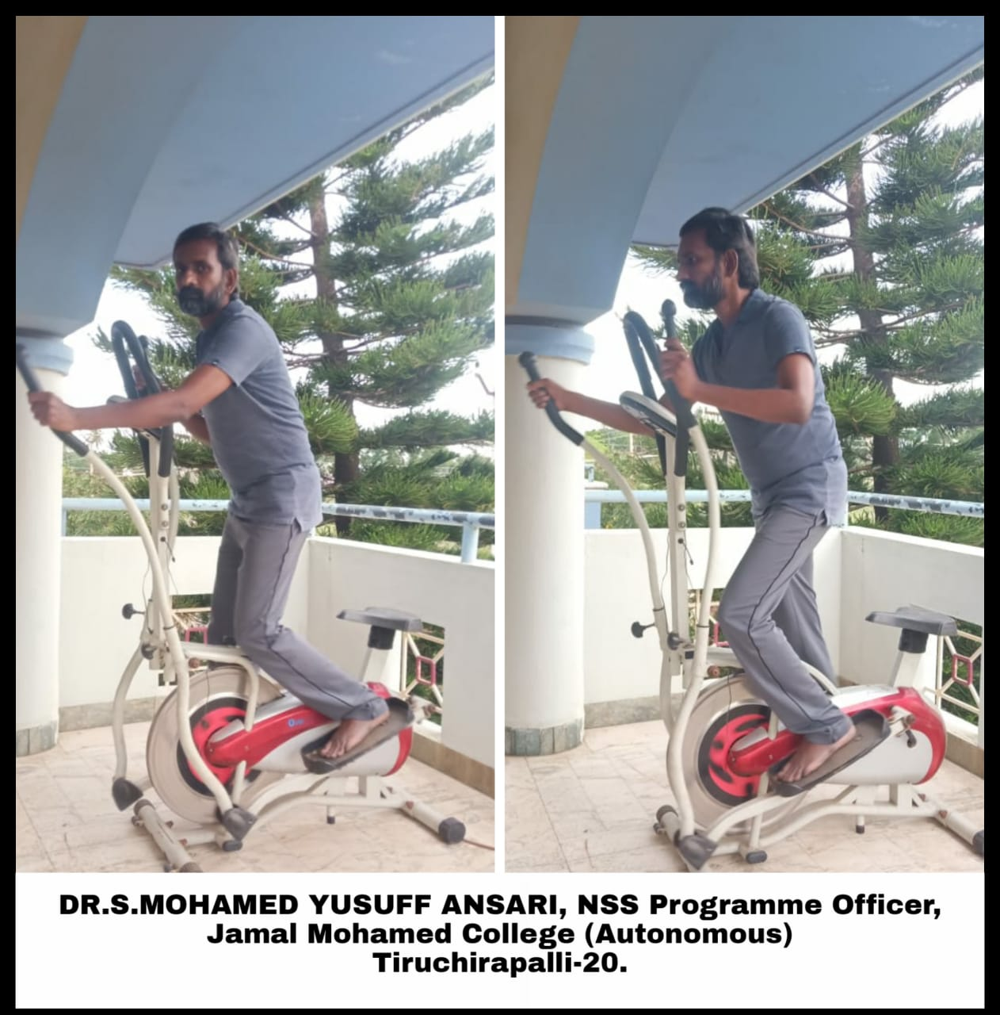

Date : 05.09.2020
TEACHER'S DAY

On the date of 05.09.2020, the Teachers Day was celebrated by National Service Scheme of Jamal Mohamed college. NSS programme officers and NSS volunteers showed their respect to their teachers on video and photo with teachers name on board.
Total no. of volunteers participants : 15

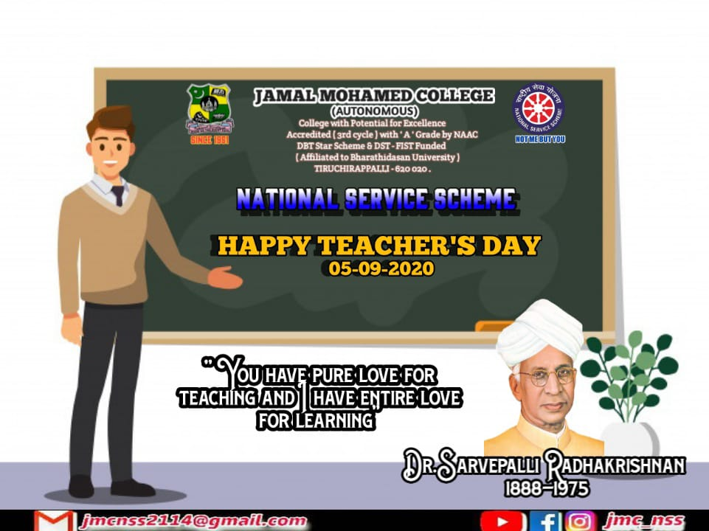

Date : 08.09.2020
LITERACY DAY
On the date of 08.09.2020, the Literacy Day was celebrated by National Service Scheme of Jamal Mohamed college. NSS programme officers and NSS volunteers take pledge on literacy day quote's and put sign on the board.
Total no. of volunteers participants : 15

Date : 08.10.2020
COVID-19 PLEDGE
Our Honorable Prime Minister launched a new Champaign on COVID-19 on the date of 08.10.2020. The Ministry of Youth Affairs and Sports conducted a pledge taking Champaign. The NSS Programme Officers and NSS volunteers participated in the campaign and took the pledge on 08.10.2020 at 1.00 P.M.

Date: 15.10.2020
YOUTH AWAKENING DAY CELEBRATION
On the date of 15.10.2020, the Dr.A.P.J Abdul Kalam birthday was celebrated by conducting webinar on the title "YOUTH AWAKENING DAY 2020'' by National Service Scheme of Jamal Mohamed College(Autonomous),Trichy.Our College Principal presided over the function. NSS Programme Officers and NSS volunteers were participated in the Webinar.
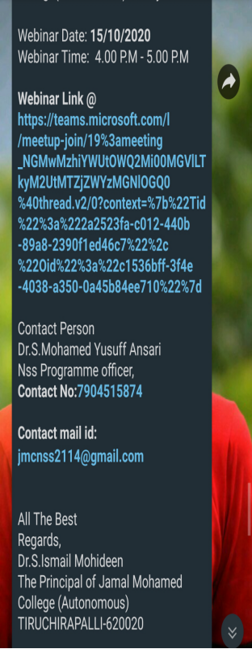

Date : 02.11.2020
Integrity pledge for citizens
On the date of 02.11.2020, integrity pledge for citizen was taken by National service scheme of Jamal Mohamed College (Autonomous) Trichy. The Government of India was observed Vigilance Awareness Week form 27.10.2020 to 02.11.2020. I am and my college nss volunteers are take pledge.

Date: 28.10.2020 - 02.11.2020
VIGILANCE AWARENESS WEEK 2020
QUIZ COMPETITION
On the date of 28.20.2020, the World Nature Conservation Day Quiz competition was conducted by NSS of Jamal Mohamed College through online mode. The competition link was circulated all over Tamil Nadu on 28.10.2020 and the link was closed on 02.11.2020. The Competition link was sent through Whatsapp group.The E-Certificate provided to the participants who got 40 and above points. NSS Programme Officers, NSS Volunteers, Faculty members and other students participated in this Quiz competition.

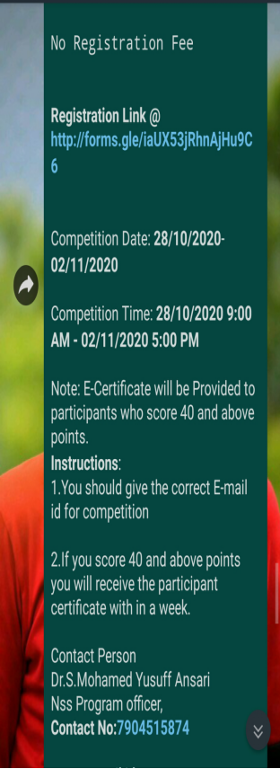
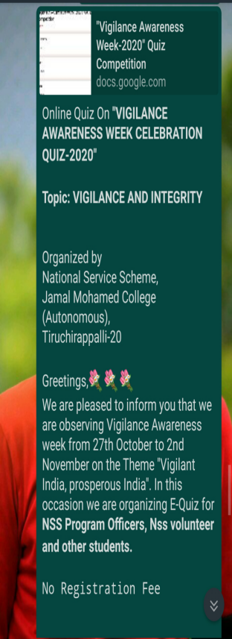
Date : 31.10.2020
National unity DAY pledge
The Govt. of India observes 31st Oct.2020 all over the country as a day of special occasion to foster and reinforce our Commitment to preserve and strengthen Unity, integrity and security of our Nation by celebrating it as Rashtriya Ekta Diwas (National Unity Day) to commemorate the Birth Anniversary of Sardar Vallabhbhai Patel. Our college NSS Volunteers were participated in this pledge with full involvement.
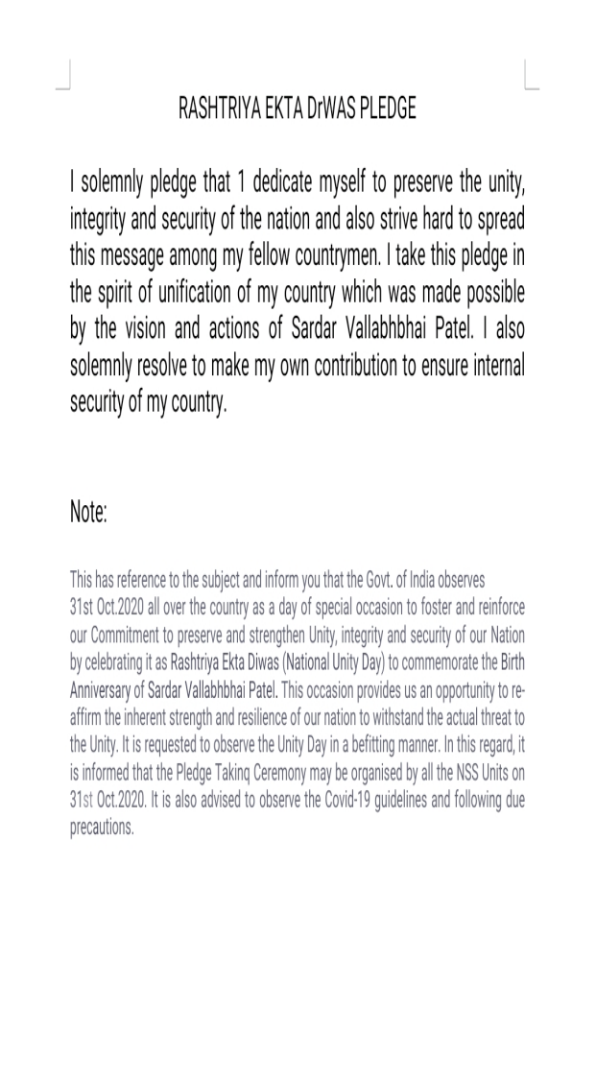
Date: 26.11.2020
WEBINAR ON CELEBRATION OF INDIAN CONSTITUTION DAY
On the date of 26.11.2020, The Constitution Day programme was celebrated by National Service Scheme of Jamal Mohamed College(Autonomous),Trichy. Our College Principal presided over the function. NSS Programme Officers and NSS volunteers were participated in the Webinar.

Date : 07.01.2021
ORIENTATION PROGRAMME AND ROAD SAFETY AWARENESS PROGRAMME
On the date of 07.01.2021, the Orientation programme and Road Safety Awareness Programme was celebrated by National Service Scheme of Jamal Mohamed College(Autonomous),Trichy.Our College Principal presided over the function. NSS Programme Officers and NSS volunteers were participated in the Webinar. We organaized this program very well.
Chief Guest of the Webinar :. Dr.A.Lakshmi Prabha
Professor and Head Department of Botany
Co ordinator National Service Scheme
Bharathidasan University
Tiruchirappalli
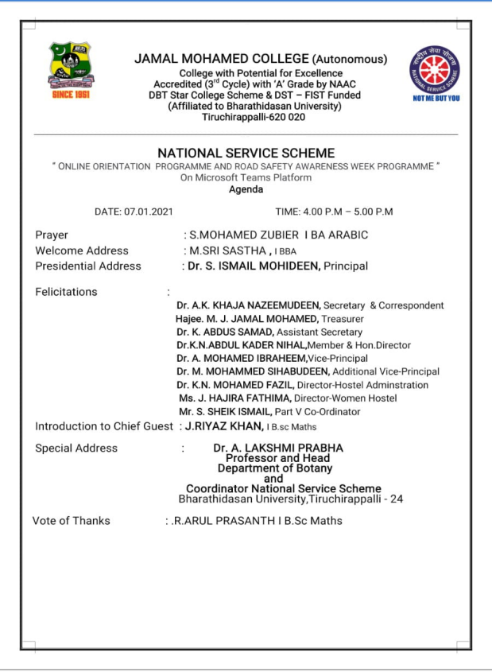

Date: 26.01.2021
REPUBLIC DAY PROGRAM
On the date of 26.01.2021, The Republic Day programme was celebrated by Jamal Mohamed College(autonomous). The National Service Scheme of Jamal Mohamed College joined and organized in this programme . Our college management committee presided over the programme. Our NSS Volunteers organaized the programme very well.
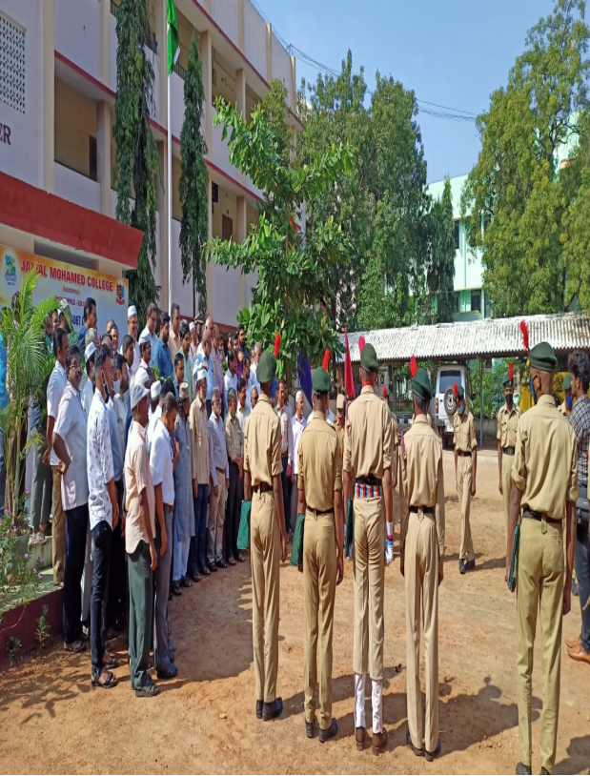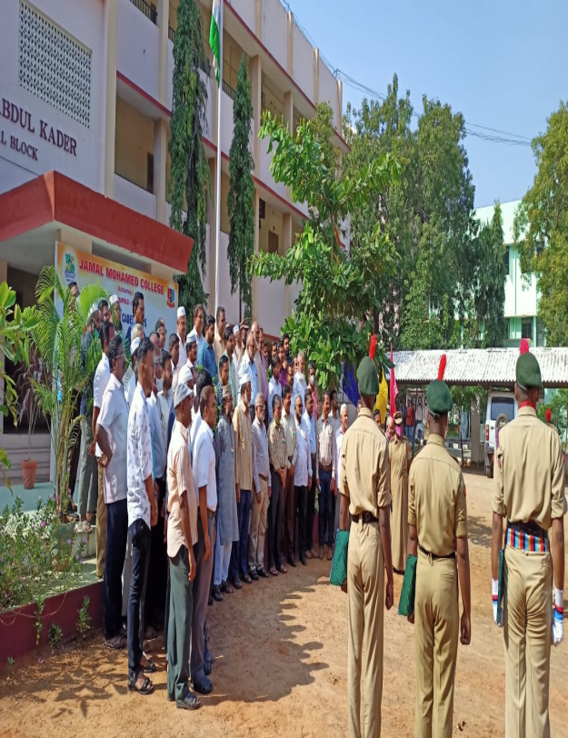
Date: 26.01.2021
VOTER'S PLEDGE
On the date of 26.01.2021, the Voter's Pledge programme was taken by National Service Scheme of Jamal Mohamed College(Autonomous) Trichy. Our College Secretary, Treasure, Principal presided over the pledge. NSS Programme Officers and NSS volunteers were taken Pledge in our College.

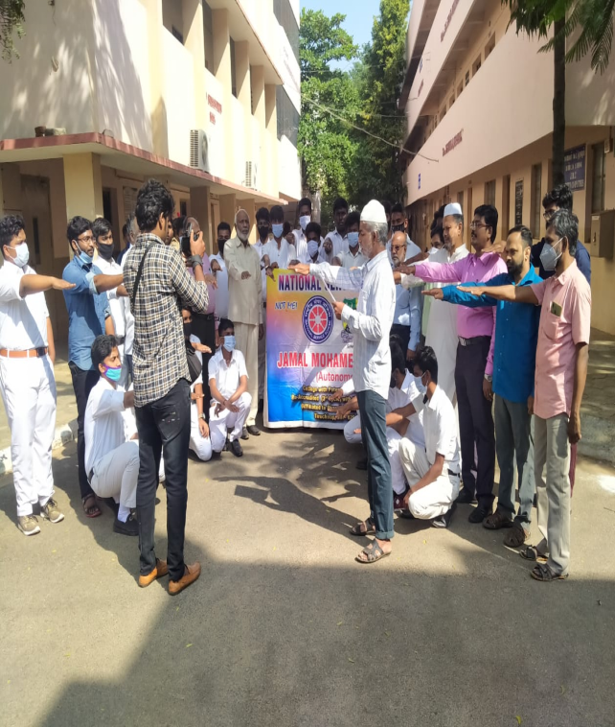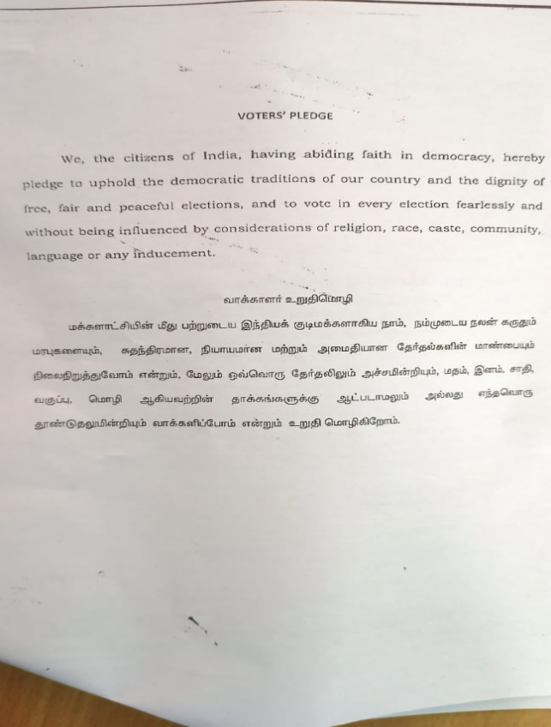
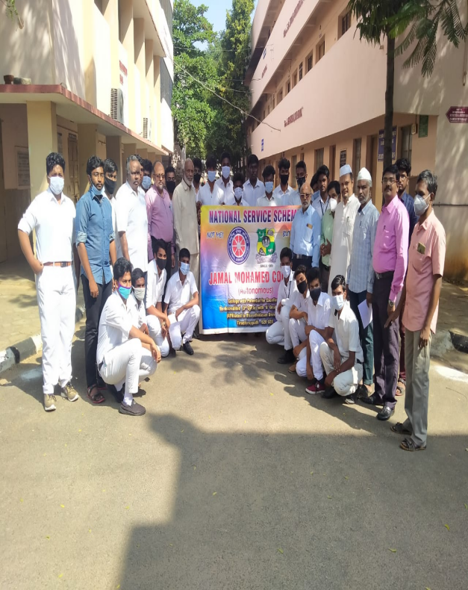

Date: 12/08/2020
INTERNATIONAL YOUTH DAY PROGRAM
On the date of 12.08.2020, the International Youth Day Programme was conducted by National Service Scheme of Jamal Mohamed College(Autonomous), Trichy .Our College Treasure, Principal and Vice-Principal presided over the programme. NSS Programme Officers and NSS volunteers were planted trees in their homes.
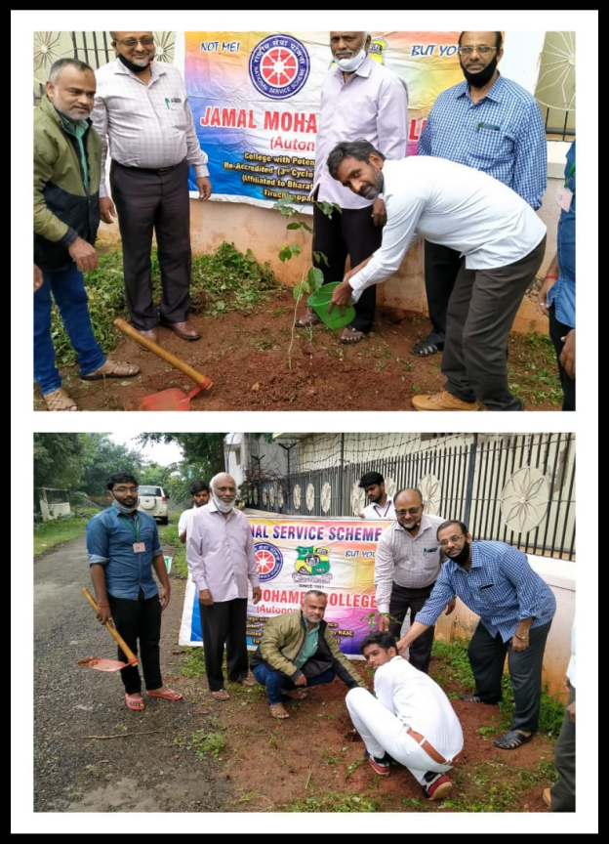

Date: 02.03.2021
FIT INDIA AWARENESS CAMPAIGN

On the date of 02.03.2021, The NSS cell of Bharathidasan University conducted Fit India Awareness Campaign at Bharathidasan University. The National Service Scheme of Jamal Mohamed College Volunteers were jointly organized the Programme. The Vice Chancellor of Bharathidasan University DR.M.SELVAM Presides over the Programme. In this programe Our NSS volunteers performed well.
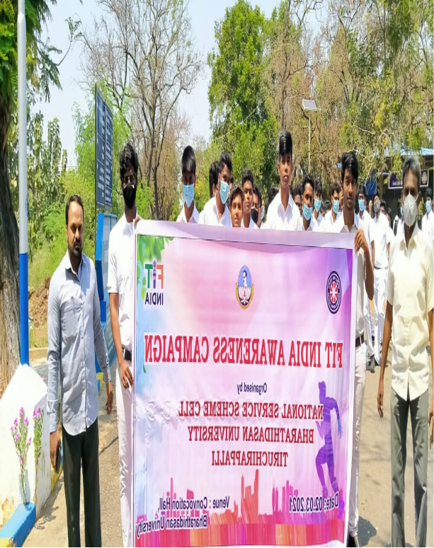

Date: 10.03.2021
ONE DAY AWARENESS PROGRAMME ON
"MENSTRUAL HYGIENE MANAGEMENT FOR ADOLESCENT GIRLS"
On the date of 10.03.2021, The NSS cell of Bharathidasan University conducted One day Awareness Programme on MENSTRUAL HYGIENE MANAGEMENT FOR ADOLESCENT GIRLS at Bharathidasan University. The women volunteers from various colleges were participated in this programme. The National Service Scheme of Jamal Mohamed College joined and organized the Programme with instructions of Seniors.
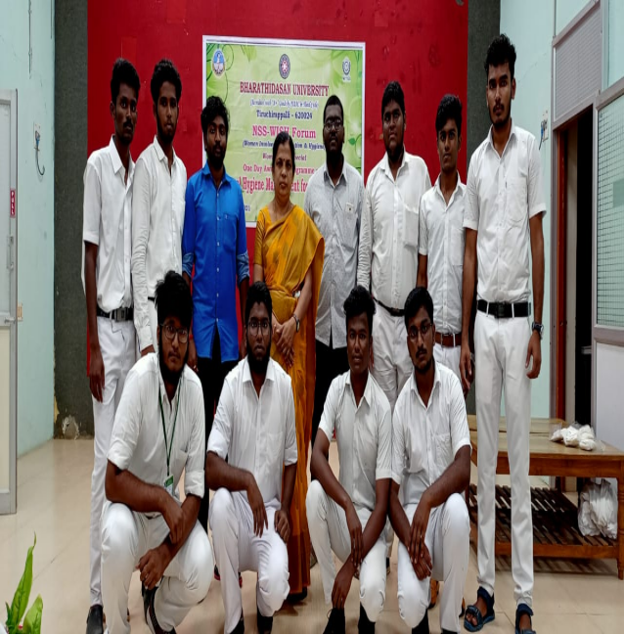

Date: 12.03.2021
UPPU SATYAGRAHA WALKING RALLY
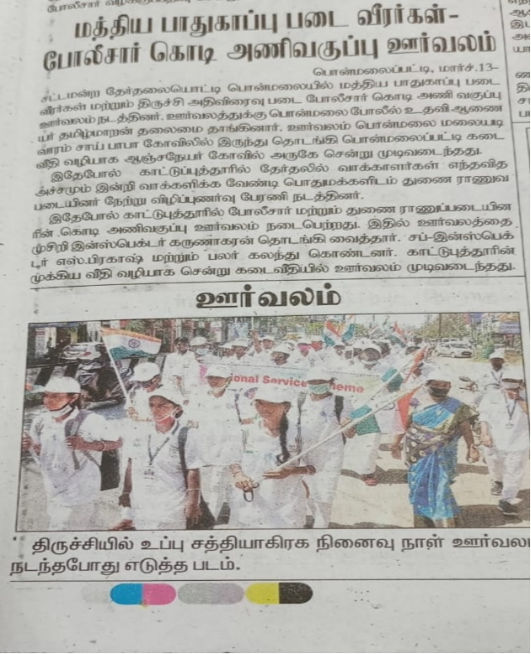
On the date of 12.03.2021, The NSS cell of Bharathidasan University conducted UPPU SATYAGRAHA WALKING RALLY At trichy junction to Gandhi market. The National Service Scheme of Jamal Mohamed College Volunteers were participated in this Rally. Trichirapalli District collector Mr.S.SIVA RASU IAS and Trichirapalli Commissioner Dr.J.LOGANATHAN IPS presided over the programme. In this programme, Our NSS volunteers did their best.

